**A**

**Project Report**

**on**

**Security Analysis In the Healthcare**

**Developed By**

***Sasank Devarakonda [210511207007]***

***Raginaboyina Nagarjuna Yadav [210511211045]***

**as**

**Partial Fulfillment of Semester IV of**

**Master of Computer Applications / Master of Science in information Technology**

**for A.Y. 2021 - 2023**

**Under the Guidance of**

**Prof. Vipul Gamit**

**Submitted To**

**Department of MCA**

**Faculty of IT & Computer Science**

**PARUL University**





**CERTIFICATE**

This is to certify that **Mr. Sasank Devarakonda,210511207007 Mr. Raginaboyina Nagarjuna Yadav,210511211045** Students of Master of Computer Applications and/or Master of Science in Information Technology has satisfactorily completed the Minor Project on **“Security Analysis In The Health Care”** at **Faculty of IT & Computer Science,** **Parul University** as partial fulfillment of MCA and/or M.Sc. (IT) Semester IV.

Seat No. _______________ Date of Submission: ____________

_______________ _______________

Internal Guide Dean - FITCS

**Faculty of IT & Computer Science**

**PARUL University, Vadodara**

**Preface**

This report has been prepared as part of my minor project, as a part of MCA/MSc-IT. The report is prepared with the view to include all the detail regarding the project that we carried out.

This project is prepared for the Event Management. The name of project is “**Security Analysis In The Health Care”** in this project we provide mainly three kinds of facilities. In this documentation the user knows that what types of facilities we providing and they can see our service as well as demo pictures also there. The service customer getting from this website is like booking doctor Appointment. They can book all service together also.

In this project we are creating something deferent and unique things.

**Acknowledgement**

The satisfaction that accompanies the successful completion of this project would be in complete without the mention of the people who made it possible, without whose constant guidance and encouragement would have made efforts go in vain. I consider myself privileged to express gratitude and respect towards all those who guided us through the completion of this project.

I convey thanks to The Dean of The Department **Dr.Priya Swaminarayan** and the Respected HOD **Pro. Vivek Dave** andmy project guide **Pro.Vipul Gamit** of Parul institute of Engineering and Technology and Parul institute of computer and application for providing encouragement, constant support and guidance which was of a great help to complete this project successfully.

Last but not the least, we wish to thank our parents for financing our studies in this college as meaning our well as for constantly encouraging us to engineering. Their personal sacrifice in providing this opportunity to learn engineering is gratefully acknowledged.

**Abstract**

Here the project says that the security measures of all web transactions not only in health sector but in all sectors should always be taken and constantly updated due to the fact that new electronic threats appear every day. Only under this condition, cloud services have positive impact to health, saving more lives than in the past instantly.

The contribution of cloud-based services in the healthcare environments is a vital issue in the 21st century. So we provides and presenting its benefits and tools in hospitals, clinics as well as diagnostic centers, Earlier year existing applications and services are separated in categories, which basically concern data storage, computing power, network, PaaS, SaaS, data analytics, business intelligence and project management. Then, some security and risk assessment issues in cloud-based services are analyzed thoroughly together with some case studies.

**INDEX**

|  |  |  |
| --- | --- | --- |
| **No.** | **Description** | **Page No.** |
| **1.** | **About Department of MCA** | **1** |
| **2.** | **Company Profile** |  |
| **3.** | **Project Profile**  3.1 Project Definition  3.2 Project Description  3.3 Existing System  3.4Features  3.5 Scope  3.6 Outcomes  3.7 Tools & Technology used  3.8 Project Plan | **2** |
| **4.** | **Requirement Analysis**  4.1 Feasibility Study  4.2 Users of the System  4.3 Modules  4.4 Hardware & Software Requirements  4.5 Use Cases  4.6 Use Case Diagram | **4** |
| **5.** | **Design**  5.1 Use Case Scenarios  5.2 Diagrams  5.2.1 UML / DFD  5.2.2 Entity Relationship Diagram  5.3 Data Dictionary | **7** |
| **6.** | **Implementation**  6.1 Form Layouts  6.2 Report Layouts  6.3 Coding Convention (Business Logic) | **11** |
| **7.** | **Testing**  7.1 Test Strategy  7.2 Test Cases | **28** |
| **8.** | **Future Enhancement** |  |
| **9.** | **Bibliography** |  |

|  |  |
| --- | --- |
| About Department | **[2022-2023]** |

**About Department of MCA & M.Sc. IT**

**PARUL University**

Parul University is a legitimate university established under Gujarat Private University Act 2009, after legislation passed by the Government of Gujarat on 26th March 2015 giving University status to Parul Group of Institutes functioning under the aegis of Parul Arogya Seva Mandal Trust.

**Faculty of IT & Computer Science**

Faculty of IT and Computer Science, Parul University has materialized as one of the prime IT education providers at global level. Various departments under Faculty of IT and Computer Science strive in preparing IT-industry ready professionals by means of various skill development courses, vocational courses, co-curricular & extra-curricular activities, industry visits and expert lectures.

**MCA Department**

The Department of Master of Computer Application and Master of Science in Information Technology at Parul University emphasizes on building professionals in the domain of computer applications by providing necessary environment by means of facilitating suitable blend of technical and non-technical learning experience. The department cultivates students in various curricular, co-curricular and extra-curricular activities in order to produce future system analysts, system designers, system programmers, application programmers, testing professionals, system managers, project managers, researchers and other leading positions in systems/IT department.

The departments offers various subjects from diversified technical/non-technical areas such as – core IT domain, management, communication skills, mathematics & logic building and rich pool of elective subjects.

The department of MCA and M.Sc. (IT) focuses on project-based learning, and hence students are motivated to work on tiny hands-on projects in practical oriented subjects to get better exposure. Moreover, throughout their MCA studies, students are required to work on around 3 mini/major projects in individual/team to get enough confidence on software-development and thereby become industry-ready.

1

Security Analysis in The Health Care

|  |  |
| --- | --- |
| Introduction | **[2022-2023]** |

**INTRODUCTION**

**2.1 PROJECT DEFINITION:** The main objective of this project “Achieves security and risk assessment issues in cloud-based services and also offers an eye-catching categorization of cloud benefits and threats in the healthcare sector providing many important tools and applications.”

**2.2 PROJECT DESCRIPTION** **:** Nowadays, cloud computing has interfered in all sectors of human life. Marketing, education as well as healthcare are three of them which have been web digitalized. As far as the healthcare is concerned, considering how many diagnostic tests and therapies, like myopia laser and axis tomography, were not feasible until the 90s decade, is enough in order the importance of cloud services to be conceptualized. This happens because such clinical operations require storage of many patients’ data (e.g. records from medical ultrasounds) and simultaneously an easy, fast access to them. This can be achieved only through secured cloud systems. Imagine for a moment how many terabytes in external or portable disk drives would be necessary for every hospital and every doctor if the interactive cloud storage systems did not exist.

**2.3 EXISTING SYSTEM:** Nowadays, cloud computing has interfered in all sectors of human life.

**2.3.1 Limitations of Existing System:** Lack of Modern Techniques and Facilities: These centers lack modern techniques and medical facilities like.

1) CT-Scan

2)X-Rays

3) Blood Testing

**2.4 Features:**

* Data analytics
* Collaborative care
* Cost control

**2.5 Scope:** Today, as digitalization spreads rapidly, data breaches and cyber-attacks have become much more common and patient information has become riskier than ever before.

**2.6Outcomes:**

[1. It’s has Remains Open 24/7](https://wptravelengine.com/benefits-of-online-booking-system/#1_Your_Business_Remains_Open_247)

[2. Online Booking Leads to Faster Payments](https://wptravelengine.com/benefits-of-online-booking-system/#2_Online_Booking_Leads_to_Faster_Payments)

2

Security Analysis in The Health Care

**2.7 TOOLS, TECHNIQUES, AND METHODOLOGIES:**

**Tools -** SQA software tools include, but are not limited to, operating system utilities, debugging aids, documentation aids, checklists, structuring preprocessors, file comparators, structure analyzers, code analyzers, standards auditors, simulators, execution analyzers, performance monitors, statistical analysis packages, software development folder/files, software traceability matrices, test drivers, test case generators, static or dynamic test tools, and information engineering CASE tools.

**Techniques -** techniques include review of the use of standards, software inspections, requirements tracing, requirements and design verification, reliability measurements and assessments, and rigorous or formal logic analysis.

**Methodologies -** methodologies are an integrated set of the above tools and techniques. The methodologies should be well documented for accomplishing the task or activity and provide a description of the process to be used. Where applicable, SQA will use SEPO organizational processes and tailor the processes specific to the project.

**2.8 PROJECT PLAN:** The project aims at relieving the user of the hardships, mentioned above in the existing system. They will be provided with the details of the next available patients immediately so that they can plan their patients’ appointments accordingly. It is an easy-to-use application and any person with an internet access can use it. The patients can easy to book the appointments.

**2.8.1 Advantages of Proposed System**

• It is very simple to use.

• It is a relatively fast approach to know the Doctor timings.

• Is highly reliable, unless for network failure.

|  |  |
| --- | --- |
| Introduction | **[2022-2023]** |

3

Security Analysis in The Health Care

**Requirement Analysis**

|  |  |
| --- | --- |
| Requirement Analysis | **[2022-2023]** |

**3.1 FEASIBILITY STUDY:** Feasibility analysis begins once the goals are defined. It starts by generating broad possible solutions, which are possible to give an indication of what the new system should look like. This is where creativity and imagination are used. Analysts must think up new ways of doing things- generate new ideas. There is no need to go into the detailed system Security Analysis in The Health care. The solution should provide enough information to make reasonable estimates about project cost and give users an indication of how the new system will fit into the organization. It is important not to exert considerable effort at this stage only to find out that the project is not worthwhile or that there is a need significantly change the original goal.

Feasibility of a new system means ensuring that the new system, which we are going to implement, is efficient and affordable. There are various types of feasibility to be determined. They are,

• Technical feasibility

• Operational feasibility

• Economic feasibility

**Technical feasibility:** This evaluation determines whether the technology needed for the proposed system is available and how it can be integrated within the organization. Technical evaluation must also assess whether the existing systems can be upgraded to use the new technology and whether the organization has the expertise to use it. Operational feasibility Operational feasibility covers two aspects. One is a technical performance aspect and the other is acceptance within the organization. Technical performance includes issues such as determining whether the system can provide the right information for the organizations personnel, and whether the system can be organized so that it always delivers this information at the right place and on time. Acceptance revolves around the current system and its personnel.

**Operational feasibility:** must determine how the proposed system will fit in with the current operations and what, if any, job restructuring and retraining may be needed to implement the system. Economic feasibility This evaluation looks at the financial aspects of the project. It determines whether the investment needed to implement the system will be recovered.

**Economic feasibility:** concerns return from the investments in a project. It determines whether it is worthwhile to invest the money in the proposed project or whether something else should be done with **Security Analysis in The Health Care.** To carry out economic feasibility study, it is necessary to place actual money values against any purchases or activities needed to implement the project.

4

Security Analysis in The Health Care

**3.2 USER OF THE SYSTEM:** Are statement of services the system should provide, how the system

|  |  |
| --- | --- |
| Requirement Analysis | **[2022-2023]** |

should react to inputs and how the system should behave situation. The Security Analysis in The Health Care provides the following facilities

* Adding details of new features.
* Updating Course Details.
* Updating of patients Details.
* Updating of UI

**3.3 MODULES:** The system should be designed in such a way that only authorized people should be allowed to access some modules. The records should be modified by only administrators and no one else.

The user should always be in control of the application and not the vice versa. The user interface should be consistent so that the user can handle the application with ease and speed. The application should be visually, conceptually clear.

**Administrator module:**

* Administrator ‘s Login
* Course Details
* Patient’s Details
* UI Details

**User module:**

* Search Course
* Search Appointment date
* Search timings

**3.4 Hardware & Software Requirements**

* + 1. **HARDWARE SPECIFICATION**
* Processor: I3/Intel Process
* RAM: 8GB
* Hard Disk: 50GB

**3.4.2 SOFTWARE SPECIFICATION:**

* + - Operating System: Windows 7/8/9
    - Front End: HTML, JSP
    - Scripts: Java Script
    - Technology: Phyton

5

Security Analysis in The Health Care

**3.5 USE CASES:**

* + - DFD
    - USE CASE
    - ACTIVITY DIAGRAM

**3.5.1USECASEDIAGRAM:** 

Fig.3.5.1. Use case Diagram.

|  |  |
| --- | --- |
| Requirement Analysis | **[2022-2023]** |

6

Security Analysis in The Health Care

**DESIGN**

|  |  |
| --- | --- |
| Design | **[2022-2023]** |

**4.1USE CASE SCENARIOS:**

We can use these types of use case that mentioned below.

1.CLASS DIAGRAM

2DFD

3.ACTIVITY DIAGRAM

4.E-R DIAGRAM

**4.2 DIAGRAMS:**

**4.2.1.CLASS DIAGRAM:**

In software engineering, a class diagram in the Unified Modeling Language (UML) is a type of static structure diagram that describes the structure of a system by showing the system's classes, their attributes, operations (or methods), and the relationships among the classes. It explains which class contains information.



Fig.4.2.1. Class Diagram.

7

Security Analysis in The Health Care

|  |  |
| --- | --- |
| Design | **[2022-2023]** |

**4.2.2.DFD:**

DFD graphically representing the functions, or processes, which capture, manipulate, store, and distribute data between a system and its environment and between components of a system. The visual representation makes it a good communication tool between User and System designer. Structure of DFD allows starting from a broad overview and expands it to a hierarchy of detailed diagrams. A process receives input data and produces output with a different content or form. Processes can be as simple as collecting input data and saving in the database, or it can be complex as producing a report containing monthly sales of all retail stores in the northwest region.

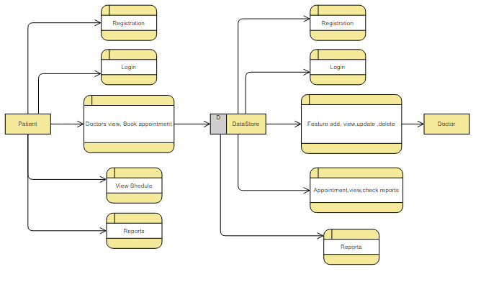

Fig.4.2.2.DFD Diagram.

8

Security Analysis in The Health Care

|  |  |
| --- | --- |
| Design | **[2022-2023]** |

**4.2.3.ACTIVITY DIAGRAM:**

Activity diagrams are graphical representations of workflows of stepwise activities and actions with support for choice, iteration, and concurrency. In the Unified Modeling Language, activity diagrams can be used to describe the business and operational step-by-step workflows of components in a system. An activity diagram shows the overall flow of control.



Fig.4.2.3. Activity Diagram.

9

Security Analysis in The Health Care

|  |  |
| --- | --- |
| Design | **[2022-2023]** |

**4.2. 4.ER DIAGRAM:**

An Entity–relationship model (ER model) describes the structure of a database with the help of a diagram, which is known as Entity Relationship Diagram (ER Diagram). An ER model is a design or blueprint of a database that can later be implemented as a database. The main components of E-R model are: entity set and relationship set.

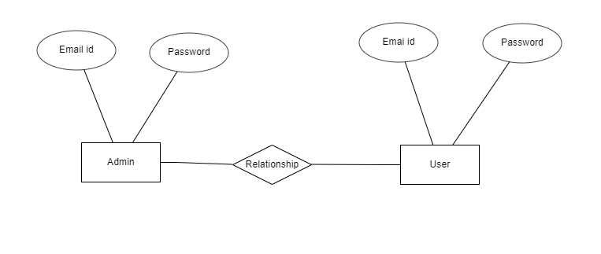

Fig.4.2.4. E R Diagram.

10

Security Analysis in The Health Care

|  |  |
| --- | --- |
| Implementation | **[2022-2023]** |

**IMPLIMENTATION**

**5.1 FORM LAYOUTS:**

**5.1.1HOME PAGE:**

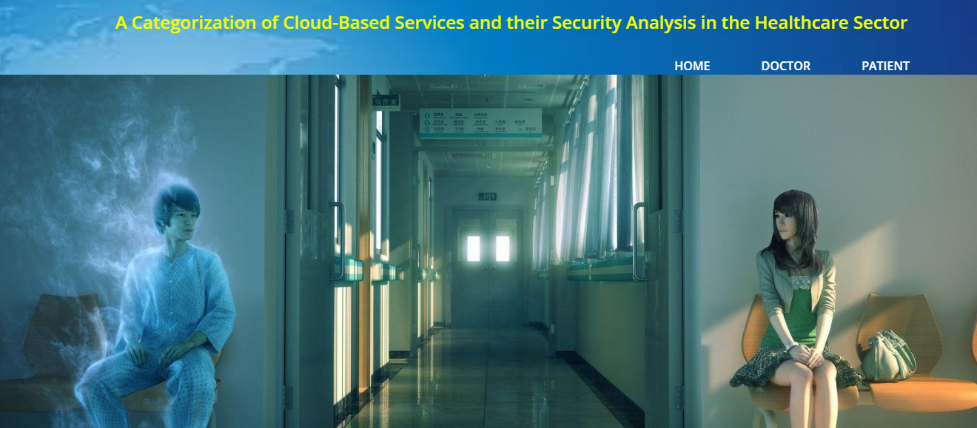

Fig.5.1. Home Page.

**5.1.2.DOCTOR REGISTRATION PAGE:**

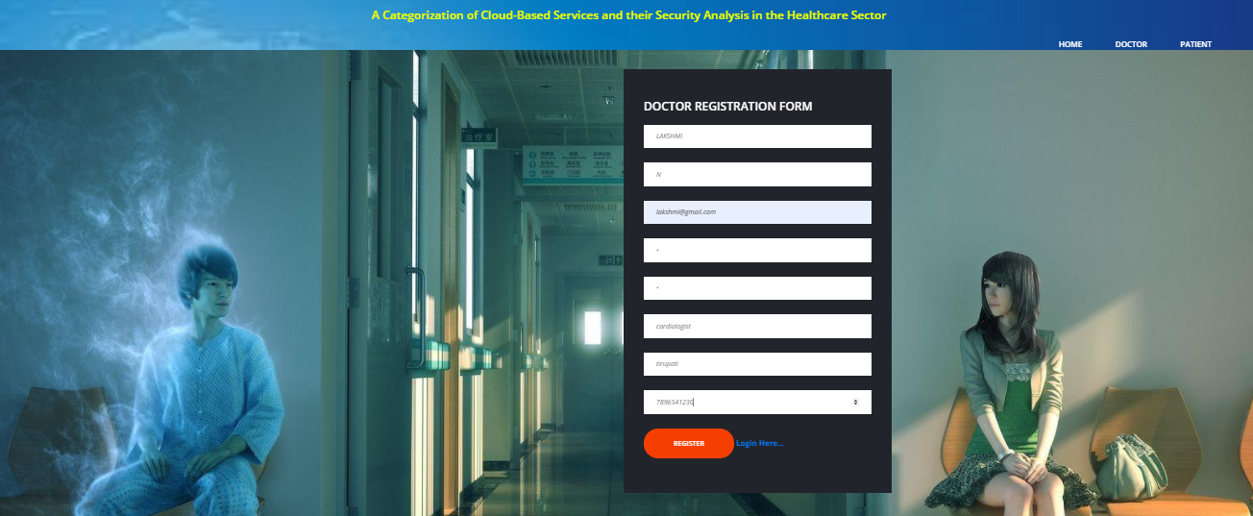

Fig.5.1.2. Registration Page.

11

Security Analysis in The Health Care

|  |  |
| --- | --- |
| Implementation | **[2022-2023]** |

**5.1.3. DOCTOR LOGIN PAGE:**

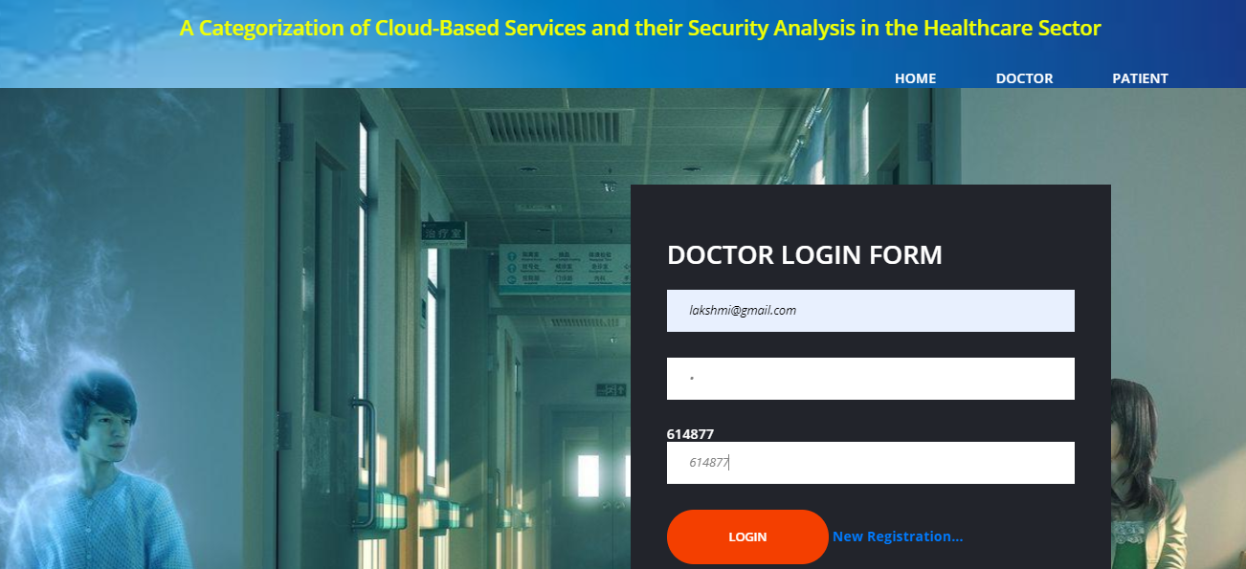

Fig.5.1.3. Doctor Login Page.

**5.1.4.DOCTOR HOME PAGE:**

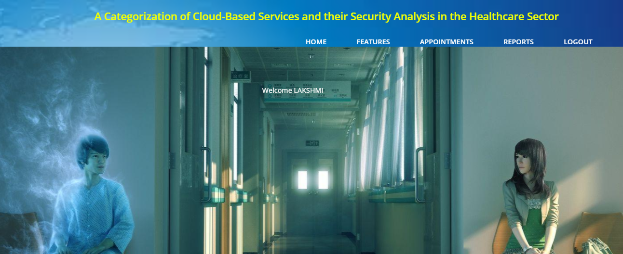

Fig.5.1.4. Doctor Home Page.

12

Security Analysis in The Health Care

|  |  |
| --- | --- |
| Implementation | **[2022-2023]** |

**5.1.5. FEATURES:**

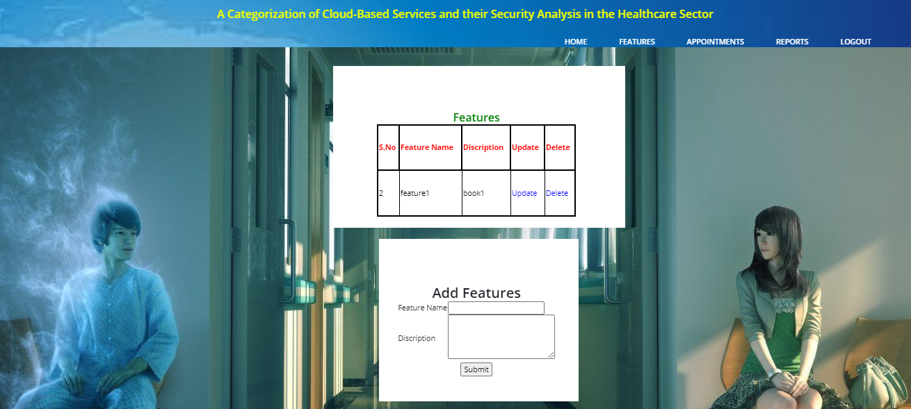

Fig.5.1.5. Features Page.

**5.1.6.APPOINTMENTS:**

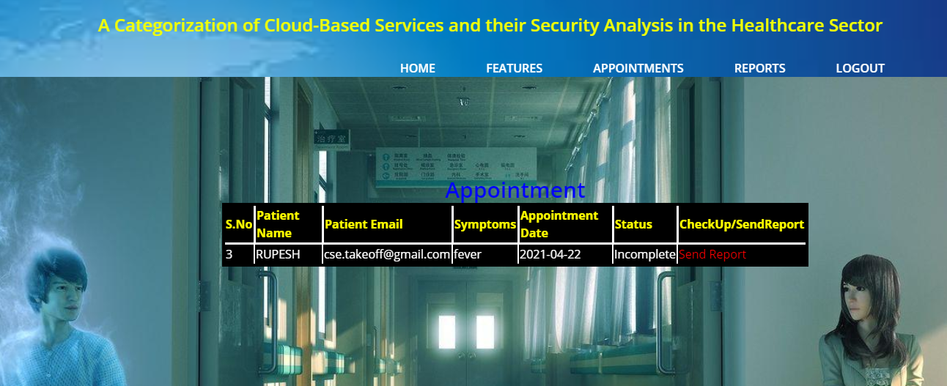

Fig.5.1.3. Appointment Page.

13

Security Analysis in The Health Care

|  |  |
| --- | --- |
| Implementation | **[2022-2023]** |

**5.1.7.REPORTS:**

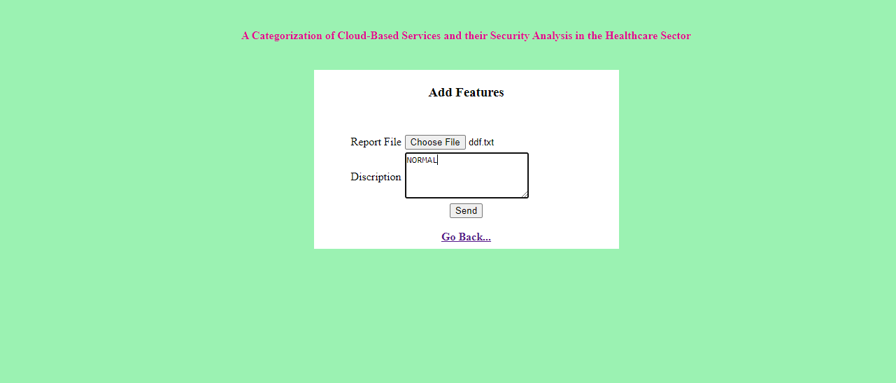

Fig.5.1.7. Report Page.

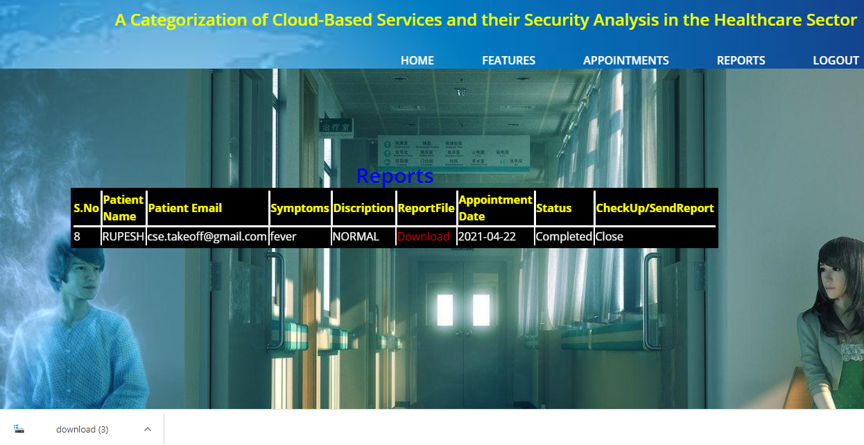

|  |  |
| --- | --- |
| Implementation | **[2022-2023]** |

Fig.5.1.7. Report Page.

14

Security Analysis in The Health Care

|  |  |
| --- | --- |
| Implementation | **[2022-2023]** |

**5.1.8. PATIENT REGISTRATION PAGE:**

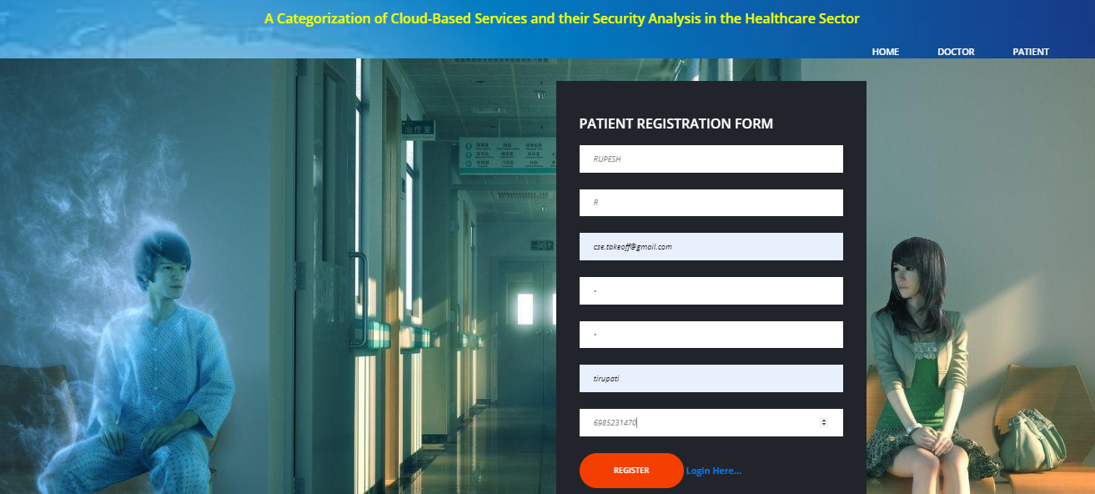

Fig.5.1.8. Patient Page.

**5.1.9. PATIENT LOGIN PAGE:**

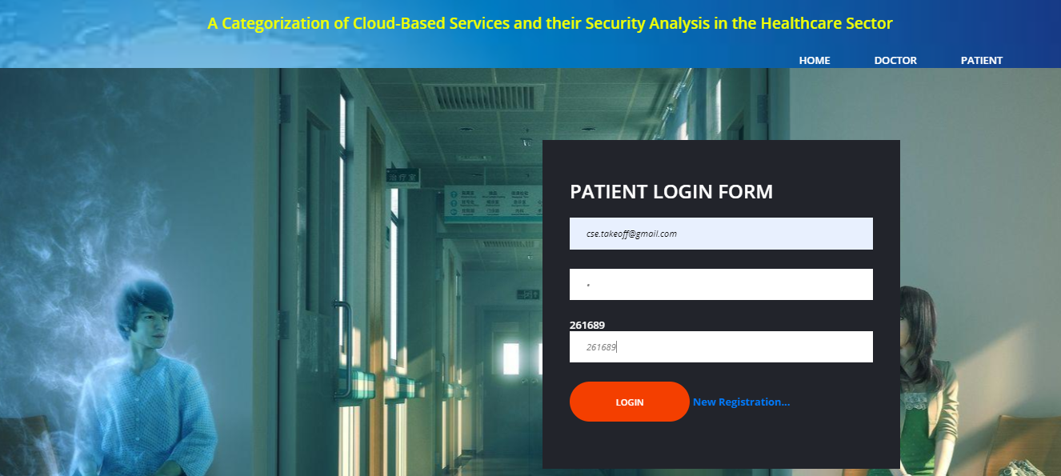

Fig.5.1.8. Patient Login Page.

15

Security Analysis in The Health Care

|  |  |
| --- | --- |
| Implementation | **[2022-2023]** |

**5.1.10. PATIENT HOME PAGE:**

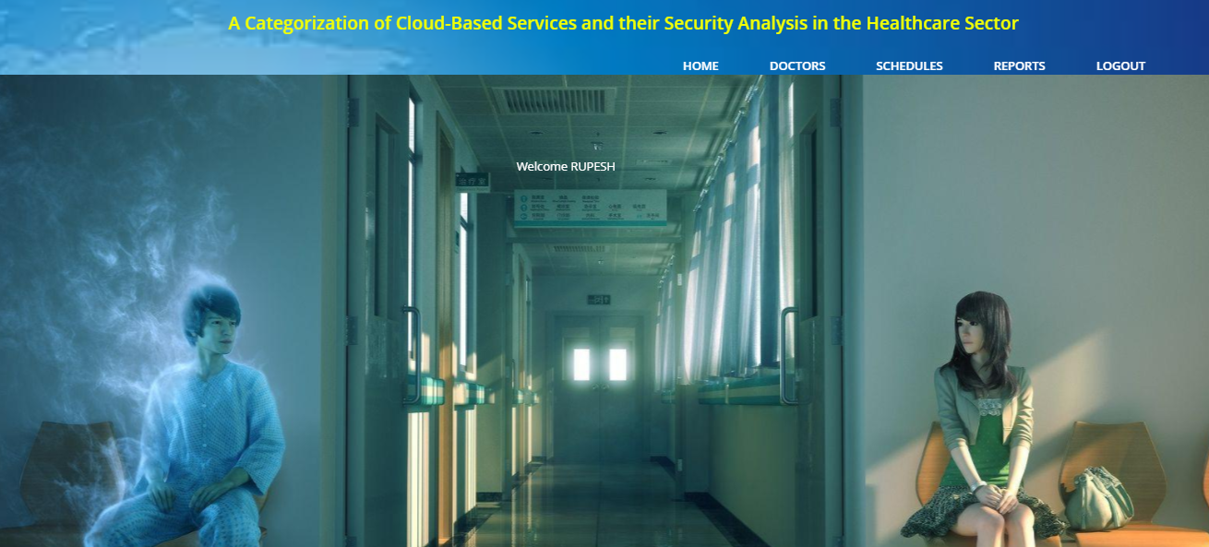

Fig.5.1.10. Patient Home Page.

**5.1.11. VIEW DOCTORS DETAILS:**

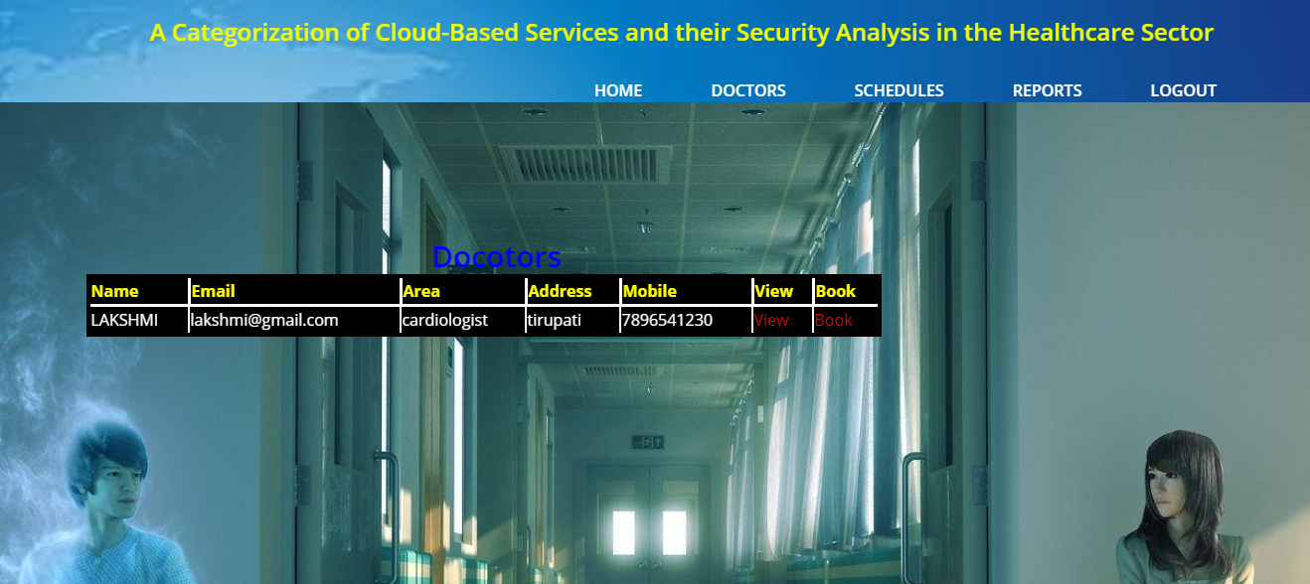

Fig.5.1.11. View Doctor Page.

16

Security Analysis in The Health Care

|  |  |
| --- | --- |
| Implementation | **[2022-2023]** |

**5.1.12. FEATURES:**

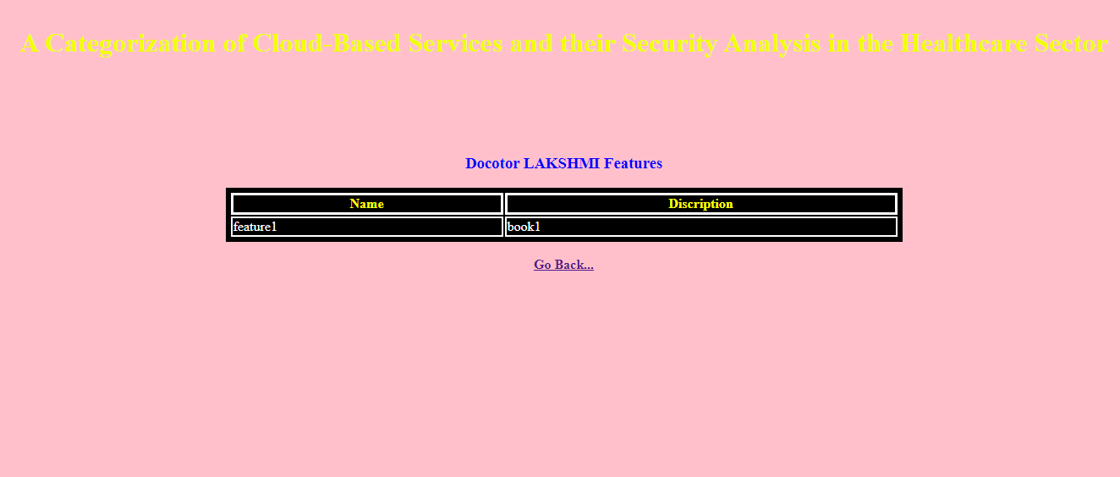

Fig.5.1.12. Features Page.

**5.1.13. SLOT BOOKING:**

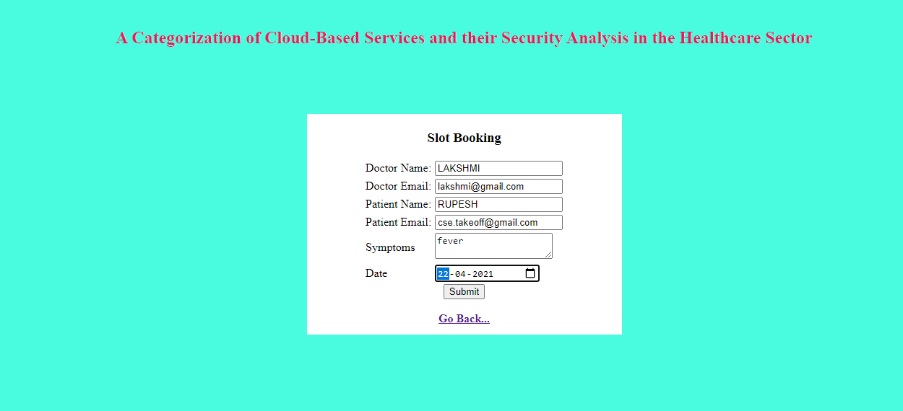

Fig.5.1.13. Report Page.

17

Security Analysis in The Health Care

|  |  |
| --- | --- |
| Implementation | **[2022-2023]** |

**5.1.14. SCHEDULES:**

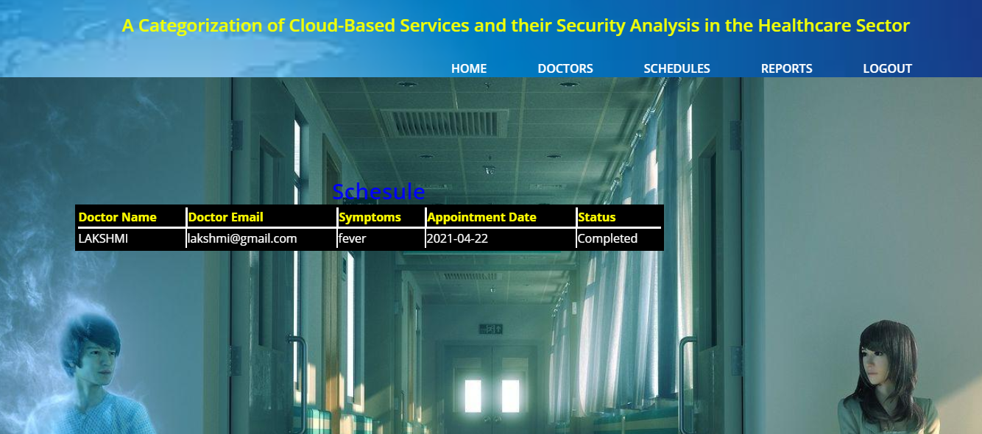

Fig.5.1.14. Schedule Page.

**5.1.15. REPORTS:**

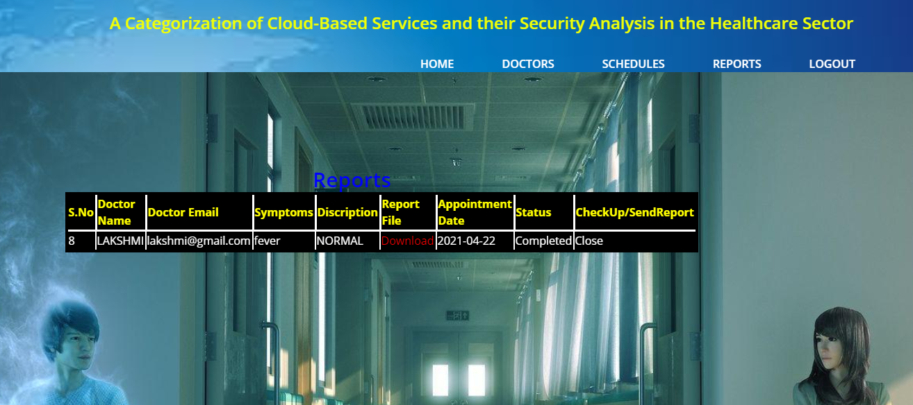

Fig.5.1.15. Report Page.

18

Security Analysis in The Health Care

|  |  |
| --- | --- |
| Implementation | **[2022-2023]** |

**5.1.16. DECRYPTION PAGE:**

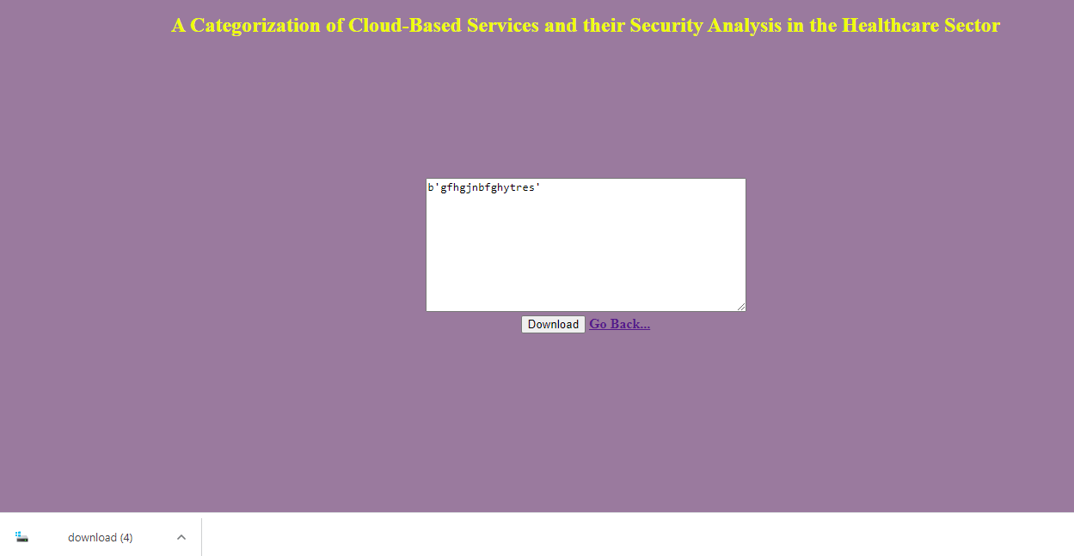

Fig.5.1.16. Decryption Page.

19

Security Analysis in The Health Care

|  |  |
| --- | --- |
| Implementation | **[2022-2023]** |

**5.1.2. OUTPUT LAYOUT:**

Output generally refers to the results and information that are generated by the system. Output is the main objective of any system and has to be in a presentable form. Almost all summaries and output are printed on the console in centrally aligned format.

All buttons are provided at the bottom of the table. The output summary of the tables and fields are displayed in a table format and the respective heading of the table are printed in bold font. The table structure gives the output a pleasing look and it is legible that the user can understand it properly.

Security Analysis In the Healthcare System is a Mobile based application that works within a centralized network. This project presents a review on the software program "Security Analysis In the Healthcare" as should be used in a Security Analysis In the Healthcare system, a facility which is used to learn music.

The software achieved can improve the customer hand and relationship management in ITC operations. It is recommended that despite the present functionality of the designed software, an additional functionality such as the use of E-mail and notifications to the customer and an online payment using credit cards/debit cards should be implemented into the system.

Furthermore, other operations carried by ITC such as the courier services should also be integrated in order to enhance the system.

20

Security Analysis in The Health Care

|  |  |
| --- | --- |
| Implementation | **[2022-2023]** |

**5.1.3. CODING CONVERTION:**

**1.Appointment:**

**Description:** Appointment coding page of Security Analysis in the Healthcare.

        <nav class="header-nav">

            <ul class="main-menu">

                <li><a href="{{ url_for('dhome') }}">HOME</a></li>

                <li><a href="{{ url_for('feature') }}">FEATURES</a></li>

                <li><a href="{{ url_for('appoint') }}">APPOINTMENTS</a></li>

                <li><a href="{{ url_for('report') }}">REPORTS</a></li>

                <li><a href="{{ url_for('index') }}">LOGOUT</a></li>

            </ul>

        </nav>

    </header>

    <!-- Header Section end -->

    <!-- Hero Section end -->

    <section class="hero-section">

        <div class="container">

            <div class="row">

                <div class="col-lg-6">

                        {% block body %}

                    {% if m=="sended report" %}

                    <div class="invalid" style="color:red">Report sended successfully</div>

                    {% endif %}

                    {% endblock %}

|  |  |
| --- | --- |
| Implementation | **[2022-2023]** |

Fig.5.1.3.1. Appointment Code Page.

21

Security Analysis in The Health Care

|  |  |
| --- | --- |
| Implementation | **[2022-2023]** |

**2.Doctor:**

**Description:** Doctor coding page of Security Analysis in the Healthcare.

<head>

    <title style="color:#FF1493">ONLINE PRODUCTS RENTAL SYSTEM</title>

    <meta charset="UTF-8">

    <meta name="description" content="loans HTML Template">

    <meta name="keywords" content="loans, html">

    <meta name="viewport" content="width=device-width, initial-scale=1.0">

    <!-- Favicon -->

    <link href="static/page-top-bg/favicon.ico" rel="shortcut icon"/>

    <!-- Google font -->

    <link href="https://fonts.googleapis.com/css?family=Open+Sans:300,300i,400,400i,600,600i,700,700i,800,800i&display=swap" rel="stylesheet">

    <!-- Stylesheets -->

    <link rel="stylesheet" href="static/css/bootstrap.min.css"/>

    <link rel="stylesheet" href="static/css/font-awesome.min.css"/>

    <link rel="stylesheet" href="static/css/owl.carousel.min.css"/>

    <link rel="stylesheet" href="static/css/flaticon.css"/>

    <link rel="stylesheet" href="static/css/slicknav.min.css"/>

    <!-- Main Stylesheets -->

    <link rel="stylesheet" href="static/css/style.css"/>

    <!--[if lt IE 9]>

        <script src="https://oss.maxcdn.com/html5shiv/3.7.2/html5shiv.min.js"></script>

        <script src="https://oss.maxcdn.com/respond/1.4.2/respond.min.js"></script>

    <![endif]-->

Fig.5.1.3.2. Doctor Code Page.

22

Security Analysis in The Health Care

|  |  |
| --- | --- |
| Implementation | **[2022-2023]** |

**3.Index:**

**Description:** Index coding page of Security Analysis in the Healthcare.

<meta name="description" content="loans HTML Template">

    <meta name="keywords" content="loans, html">

    <meta name="viewport" content="width=device-width, initial-scale=1.0">

    <!-- Favicon -->

    <link href="static/page-top-bg/favicon.ico" rel="shortcut icon"/>

    <!-- Google font -->

    <link href="https://fonts.googleapis.com/css?family=Open+Sans:300,300i,400,400i,600,600i,700,700i,800,800i&display=swap" rel="stylesheet">

    <!-- Stylesheets -->

    <link rel="stylesheet" href="static/css/bootstrap.min.css"/>

    <link rel="stylesheet" href="static/css/font-awesome.min.css"/>

    <link rel="stylesheet" href="static/css/owl.carousel.min.css"/>

    <link rel="stylesheet" href="static/css/flaticon.css"/>

    <link rel="stylesheet" href="static/css/slicknav.min.css"/>

    <!-- Main Stylesheets -->

    <link rel="stylesheet" href="static/css/style.css"/>

    <!--[if lt IE 9]>

        <script src="https://oss.maxcdn.com/html5shiv/3.7.2/html5shiv.min.js"></script>

        <script src="https://oss.maxcdn.com/respond/1.4.2/respond.min.js"></script>

    <![endif]-->

<script>

var myWindow;

Fig.5.1.3.3. Index Code Page.

23

Security Analysis in The Health Care

|  |  |
| --- | --- |
| Implementation | **[2022-2023]** |

**4.Patient:**

**Description:** Patient coding page of Security Analysis in the Healthcare.

<head>

    <title style="color:#FF1493">ONLINE PRODUCTS RENTAL SYSTEM</title>

    <meta charset="UTF-8">

    <meta name="description" content="loans HTML Template">

    <meta name="keywords" content="loans, html">

    <meta name="viewport" content="width=device-width, initial-scale=1.0">

    <!-- Favicon -->

    <link href="static/page-top-bg/favicon.ico" rel="shortcut icon"/>

    <!-- Google font -->

    <link href="https://fonts.googleapis.com/css?family=Open+Sans:300,300i,400,400i,600,600i,700,700i,800,800i&display=swap" rel="stylesheet">

    <!-- Stylesheets -->

    <link rel="stylesheet" href="static/css/bootstrap.min.css"/>

    <link rel="stylesheet" href="static/css/font-awesome.min.css"/>

    <link rel="stylesheet" href="static/css/owl.carousel.min.css"/>

    <link rel="stylesheet" href="static/css/flaticon.css"/>

    <link rel="stylesheet" href="static/css/slicknav.min.css"/>

    <!-- Main Stylesheets -->

    <link rel="stylesheet" href="static/css/style.css"/>

    <!--[if lt IE 9]>

        <script src="https://oss.maxcdn.com/html5shiv/3.7.2/html5shiv.min.js"></script>

        <script src="https://oss.maxcdn.com/respond/1.4.2/respond.min.js"></script>

    <![endif]-->

<script>

var myWindow;

Fig.5.1.3.4. Patient Code Page.

24

Security Analysis in The Health Care

|  |  |
| --- | --- |
| Implementation | **[2022-2023]** |

**5. Report:**

**Description:** Report coding page of Security Analysis in the Healthcare.

<head>

    <title style="color:#FF1493">ONLINE PRODUCTS RENTAL SYSTEM</title>

    <meta charset="UTF-8">

    <meta name="description" content="loans HTML Template">

    <meta name="keywords" content="loans, html">

    <meta name="viewport" content="width=device-width, initial-scale=1.0">

    <!-- Favicon -->

    <link href="static/page-top-bg/favicon.ico" rel="shortcut icon"/>

    <!-- Google font -->

    <link href="https://fonts.googleapis.com/css?family=Open+Sans:300,300i,400,400i,600,600i,700,700i,800,800i&display=swap" rel="stylesheet">

  <link href="https://fonts.googleapis.com/css?family=Lora:400,400i,700,700i" rel="stylesheet">

    <!-- Stylesheets -->

    <link rel="stylesheet" href="static/css/bootstrap.min.css"/>

    <link rel="stylesheet" href="static/css/font-awesome.min.css"/>

    <link rel="stylesheet" href="static/css/owl.carousel.min.css"/>

    <link rel="stylesheet" href="static/css/flaticon.css"/>

    <link rel="stylesheet" href="static/css/slicknav.min.css"/>

    <!-- Main Stylesheets -->

    <link rel="stylesheet" href="static/css/style.css"/>

    <!--[if lt IE 9]>

Fig.5.1.3.5. Report Code Page.

25

Security Analysis in The Health Care

|  |  |
| --- | --- |
| Implementation | **[2022-2023]** |

**6. Schedule:**

**Description:** Schedule coding page of Security Analysis in the Healthcare.

<head>

    <title style="color:#FF1493">ONLINE PRODUCTS RENTAL SYSTEM</title>

    <meta charset="UTF-8">

    <meta name="description" content="loans HTML Template">

    <meta name="keywords" content="loans, html">

    <meta name="viewport" content="width=device-width, initial-scale=1.0">

    <!-- Favicon -->

    <link href="static/page-top-bg/favicon.ico" rel="shortcut icon"/>

    <!-- Google font -->

    <link href="https://fonts.googleapis.com/css?family=Open+Sans:300,300i,400,400i,600,600i,700,700i,800,800i&display=swap" rel="stylesheet">

  <link href="https://fonts.googleapis.com/css?family=Lora:400,400i,700,700i" rel="stylesheet">

    <!-- Stylesheets -->

    <link rel="stylesheet" href="static/css/bootstrap.min.css"/>

    <link rel="stylesheet" href="static/css/font-awesome.min.css"/>

    <link rel="stylesheet" href="static/css/owl.carousel.min.css"/>

    <link rel="stylesheet" href="static/css/flaticon.css"/>

    <link rel="stylesheet" href="static/css/slicknav.min.css"/>

    <!-- Main Stylesheets -->

    <link rel="stylesheet" href="static/css/style.css"/>

Fig.5.1.3.6. Schedule Code Page.

26

Security Analysis in The Health Care

|  |  |
| --- | --- |
| Implementation | **[2022-2023]** |

**7. Send Report:**

**Description:** Send coding page of Security Analysis in the Healthcare.

<head>

    <title style="color:#FF1493">ONLINE PRODUCTS RENTAL SYSTEM</title>

    <meta charset="UTF-8">

    <meta name="description" content="loans HTML Template">

    <meta name="keywords" content="loans, html">

    <meta name="viewport" content="width=device-width, initial-scale=1.0">

    <!-- Favicon -->

    <link href="static/page-top-bg/favicon.ico" rel="shortcut icon"/>

    <!-- Google font -->

    <link href="https://fonts.googleapis.com/css?family=Open+Sans:300,300i,400,400i,600,600i,700,700i,800,800i&display=swap" rel="stylesheet">

  <link href="https://fonts.googleapis.com/css?family=Lora:400,400i,700,700i" rel="stylesheet">

    <!-- Stylesheets -->

    <link rel="stylesheet" href="static/css/bootstrap.min.css"/>

    <link rel="stylesheet" href="static/css/font-awesome.min.css"/>

    <link rel="stylesheet" href="static/css/owl.carousel.min.css"/>

    <link rel="stylesheet" href="static/css/flaticon.css"/>

    <link rel="stylesheet" href="static/css/slicknav.min.css"/>

    <!-- Main Stylesheets -->

    <link rel="stylesheet" href="static/css/style.css"/>

Fig.5.1.3.7. Send Report Code Page.

27

Security Analysis in The Health Care

|  |  |
| --- | --- |
| Testing | **[2022-2023]** |

**TESTING**

**6.1 TEST STRATEGY:**

The purpose of testing is to discover errors. Testing is the process of trying to discover every conceivable fault or weakness in a work product. It provides a way to check the functionality of components, sub-assemblies, assemblies and/or a finished product It is the process of exercising software with the intent of ensuring that the

Software system meets its requirements and user expectations and does not fail in an unacceptable manner. There are various types of tests. Each test type addresses a specific testing requirement.

**TYPES OF TESTS**

**6.1.1. Unit testing**

Unit testing involves the design of test cases that validate that the internal program logic is functioning properly, and that program inputs produce valid outputs. All decision branches and internal code flow should be validated. It is the testing of individual software units of the application .it is done after the completion of an individual unit before integration. This is a structural testing, that relies on knowledge of its construction and is invasive. Unit tests perform basic tests at component level and test a specific business process, application, and/or system configuration. Unit tests ensure that each unique path of a business process performs accurately to the documented specifications and contains clearly defined inputs and expected results.

**6.1.2. Integration testing**

Integration tests are designed to test integrated software components to determine if they actually run as one program. Testing is event driven and is more concerned with the basic outcome of screens or fields. Integration tests demonstrate that although the components were individually satisfaction, as shown by successfully unit testing, the combination of components is correct and consistent. Integration testing is specifically aimed at exposing the problems that arise from the combination of components.

28

Security Analysis in The Health Care

|  |  |
| --- | --- |
| Testing | **[2022-2023]** |

**6.1.3. Functional test**

Functional tests provide systematic demonstrations that functions tested are available as specified by the business and technical requirements, system documentation, and user manuals.

Functional testing is centered on the following items:

Valid Input : identified classes of valid input must be accepted.

Invalid Input : identified classes of invalid input must be rejected.

Functions : identified functions must be exercised.

Output : identified classes of application outputs must be exercised.

Systems/Procedures: interfacing systems or procedures must be invoked.

Organization and preparation of functional tests is focused on requirements, key functions, or special test cases. In addition, systematic coverage pertaining to identify Business process flows; data fields, predefined processes, and successive processes must be considered for testing. Before functional testing is complete, additional tests are identified and the effective value of current tests is determined.

**6.1.4. SYSTEM TEST**

System testing ensures that the entire integrated software system meets requirements. It tests a configuration to ensure known and predictable results. An example of system testing is the configuration-oriented system integration test. System testing is based on process descriptions and flows, emphasizing pre-driven process links and integration points.

**6.1.5. White Box Testing**

White Box Testing is a testing in which in which the software tester has knowledge of the inner workings, structure, and language of the software, or at least its purpose. It is purpose. It is used to test areas that cannot be reached from a black box level.

**6.1.6. Black Box Testing**

Black Box Testing is testing the software without any knowledge of the inner workings, structure or language of the module being tested. Black box tests, as most other kinds of tests, must be written from a definitive source document, such as specification or requirements document.

29

Security Analysis in The Health Care